Forging operation

Forging is a manufacturing process involving the shaping of a

metal through hammering, pressing, or rolling. These

compressive forces are delivered with a hammer or die. Forging is

often categorized according to the temperature at which it is

performed—cold, warm, or hot forging.

Cutting operation

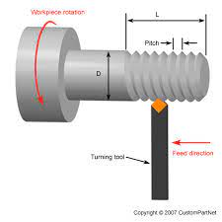

Cutting is a technique where the operator moves a material (workpiece) such as metal and the

tool in relation to each other in order to shape the workpiece into the desired form through

shaving, drilling, etc. Cutting can be broadly divided into two methods: rolling, where the

workpiece is restrained while the tools turn, and turning, where the workpiece is turned

instead.

Two methods of cutting

Rolling: Tool turns

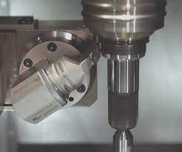

Edging operation

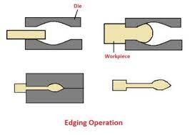

Edging – During the process work piece material is placed between the two dies and

there is striking at the edge of the material to obtain a required shape. Edging is often a

primary drop forging operation. Bending – It is a very common forging operation. It is an

operation to give a turn to metal rod and plate.

Bending operation

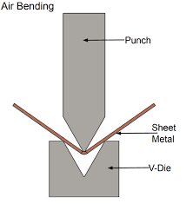

Forging is a manufacturing process involving the shaping of a metal through hammering,

pressing, or rolling. These compressive forces are delivered with a hammer or die. Forging

is often categorized according to the temperature at which it is performed—cold, warm, or

hot forging. A wide range of metals can be forged.

Punching operation

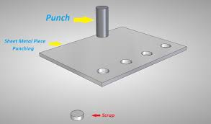

‘Punching’ and ‘drifting’ is a common practice in forgework. Punches are supplied

in a range of sections, from round and square to rectangular. Punches are used first

to drive a hole through the metal being forged, followed by a drift, which smooths

and is used to widen the ‘hole’.

This process starts with the metal being heated to yellow heat, in the forge. It is

then placed on the face of the anvil, and a punch is used to drive a hole,

approximately half way through. The metal is flipped over and the metal is

punched from the opposite side. This means that punching does not go through to

the surface of the anvil, which could damage it. ‘Punching’ must be completed

quickly, so that the temperature of the metal is maintained.